## Panpipes

The panpipes were one of the instruments considered. They consist of 15 pipes and notes would be played by blowing air across the openings of the pipes. According to research done in [1], the pipes would require about 8.5 litres per minute [1] of airflow to play higher notes.

After testing was done both on the panpipes and Tesla coils, the Tesla coils were chosen over the panpipes, but there was a considerable amount of work done on the panpipes before this decision, which will be discussed in this section.

### Versions

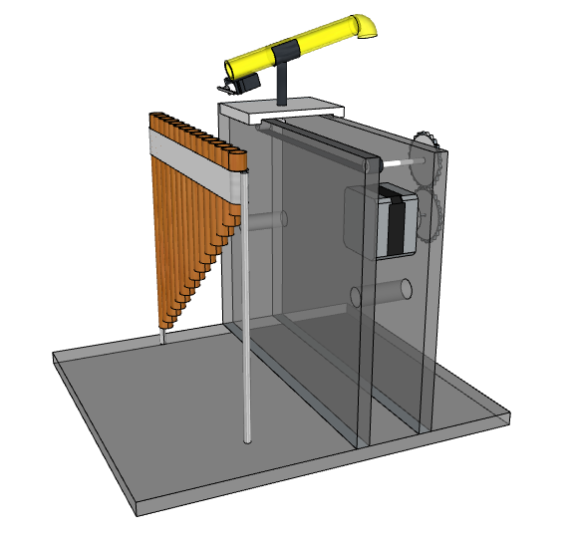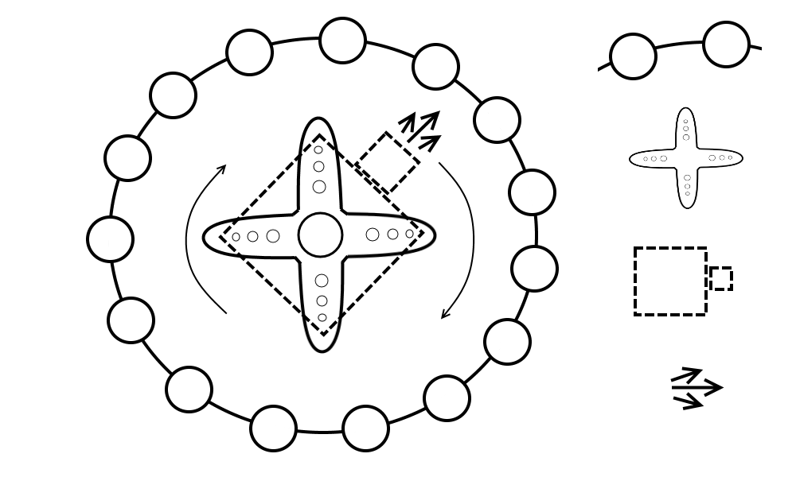There were 3 main designs for the panpipes throughout the project.

**Figure 1.1c.** Third Design.

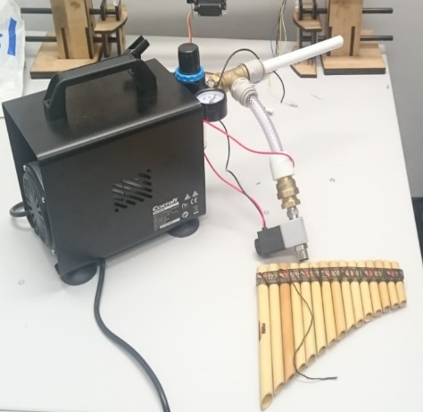

**Figure 1.1b.** Second Design.

**Figure 1.1a.** First Design.

**First design**

The initial design seen in Figure 1.1a had the panpipes fixed to a base and the nozzle that directed the air from the pump (mattress pump at the time). The nozzle was on an elevated platform that would move from side to side to play different notes and had a breaker that would cut off the airflow when the platform would be moving from pipe to pipe. This platform would be powered by a stepper motor allowing it to move to individual pipes.

This design was later changed to the second design shown in Figure 1.1b which would simplify the moving mechanism.

**Second design**

Instead of a stepper powered track moving sideways, the idea was to mount the nozzle onto a servo motor which could rotate 360 degrees. The pipes would also be taken apart and mounted in a circle around the servo with the nozzle.

This design had flaws due to the moving components and how there might been and increasing error over time of where the nozzle is aiming, to the point where the nozzle will be blowing air past the pipe. This will lead to the final design which removed most of the moving parts.

**Third design**

The final design seen in Figure 1.1c would have an air compressor providing the airflow since after tests were done it was established that the mattress pump did not provide enough pressure to produce a loud enough sound. There were to be 15 ducts to each panpipe and at the end of each duct there would be a solenoid valve that is normally closed, and when a specific note needs to be played, the valve would be turned on to let the air through.

After the final tests it was found that the pressure was still lost along the pipes and the sound made by the air coming out of the valve was still too quiet. This meant that a more expensive air compressor or better pipes needed to be bought which could lead to the risk of being over budget.

# References

[1] http://www.conservationphysics.org/flute/flute.php